Student Name :-Wageshwar Pathare

Project Name:- Ice-cream Parlour Website

Description

Ice cream parlour that offers a delightful range of ice cream flavors, sundaes, and treats for customers to indulge in. The parlour provides a cozy and inviting atmosphere for ice cream lovers to enjoy their favorite frozen desserts.

Technologies are used:

- HTML: Used for structuring the content of the website.

- CSS: Used for styling and designing the layout of the website.

-Website: A user-friendly website is maintained to showcase the menu, About us, Review and Cart.

Advantages:

-Menu Exploration: Customers can explore the variety of flavors, toppings, and products you offer at their own pace, helping them make informed choices and discover new favorites.

-Online Ordering: With online ordering options, customers can place their orders in advance, reducing wait times and ensuring their favorite treats are ready when they arrive at the parlor.

-Review: Customers can provide reviews, or inquiries through the website, enabling two-way communication between them and the ice cream parlor to enhance their experience.

Home Page

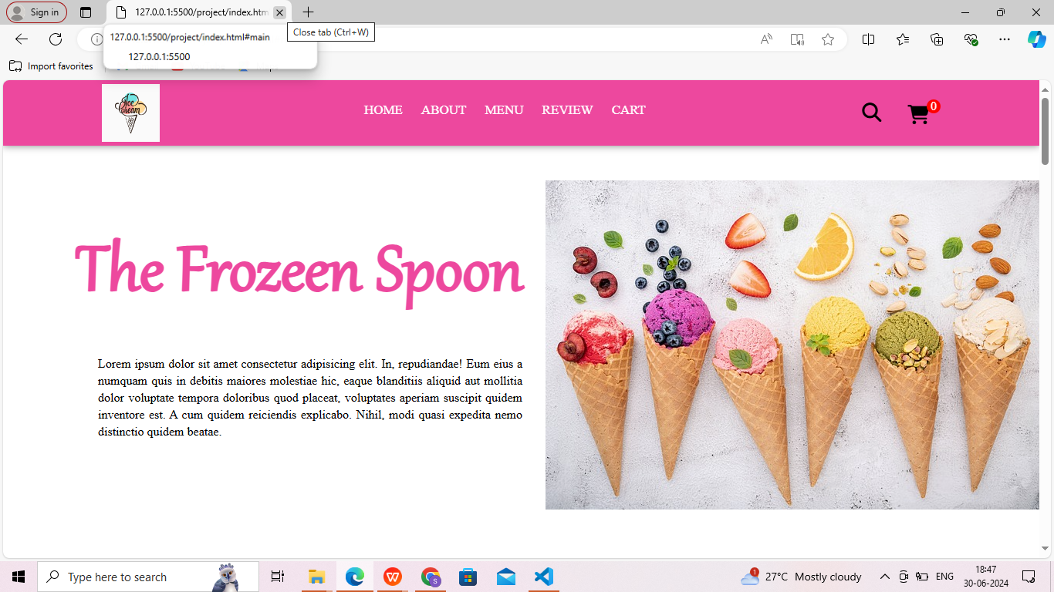

About Page

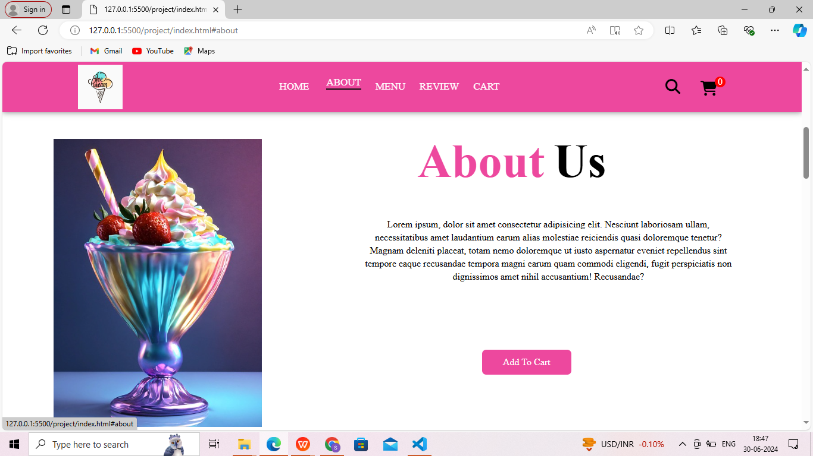

Menu Page

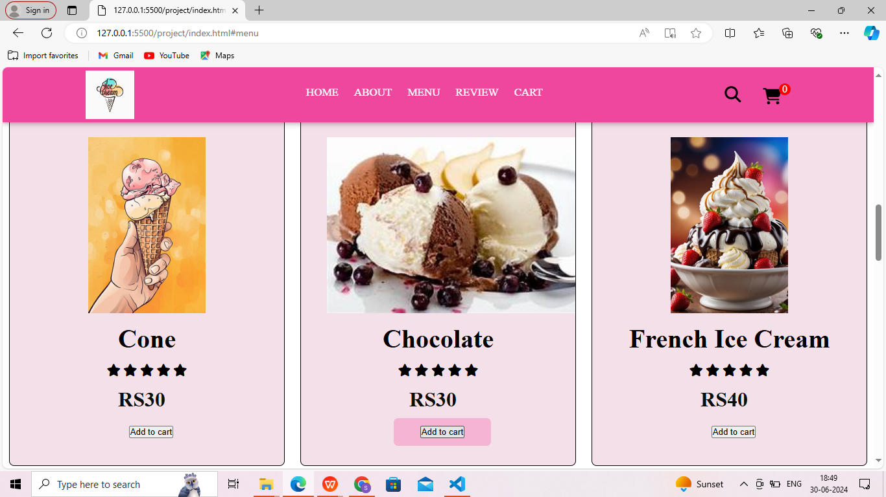

Review Page

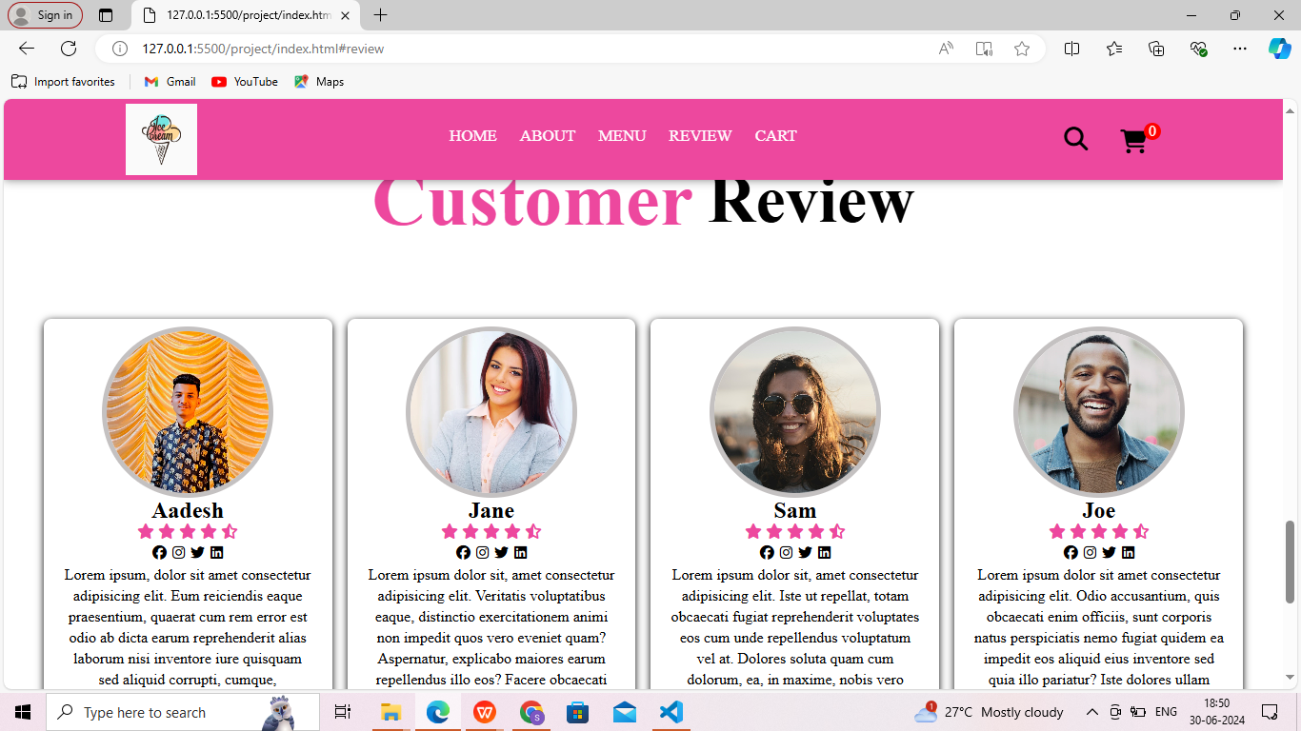

Cart Page

